
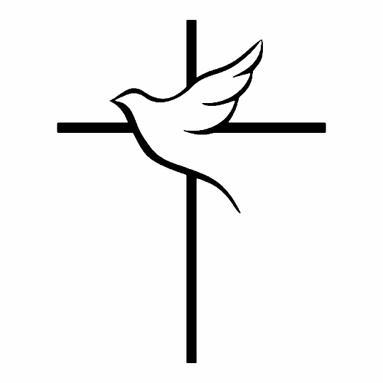
First & LAST name
DATE OF BIRTH – DATE OF DEATH

Our Lady of Mount Carmel Church
Hamden, Connecticut

INSERT
PICTURE
HERE
Mass of
Christian Burial

The LAST NAME family would like to thank you for your love, support, and attendance at the Funeral Mass this morning.

Immediately following the conclusion of the Mass, NAME OF THE DECEASED will be laid to rest in NAME OF CEMETERY. All are invited to join the family as we bring NAME to his/her final place of rest.

Eulogist: Name of Eulogist
Pall Bearers: Names of Pall Bearers
Readers: Name(s) of Reader(s)
Gift Bearers: Name(s) of Gift Bearer(s)
Celebrant: Rev. Name of Priest

ORDER OF MASS

THE INTRODUCTORY RITE

BLESSING THE BODY & SPRINKLING WITH HOLY WATER

ENTRANCE HYMN

Name of Hymn

WELCOME & INTRODUCTION

EULOGY

Name of Eulogist

OPENING PRAYER

THE LITURGY OF THE WORD

FIRST READING: Reading Citation (i.e. Wisdom 3:1-9)

Name of Reader

PSALM: Psalm 23 - The Lord Is My Shepherd

SECOND READING: Reading Citation (i.e. Romans 6:3-9)

Name of Reader

GOSPEL & HOMILY

Rev. Name of Priest

GENERAL INTERCESSIONS

Name of Reader

READER: We pray to the Lord.
ALL: Lord, hear our prayer.

THE LITURGY OF THE EUCHARIST

OFFERTORY HYMN

Name of Hymn

PRESENTATION OF THE GIFTS

Name(s) of Gift Bearer(s)

EUCHARISTIC PRAYER

THE LORD’S PRAYER

SIGN OF PEACE

LAMB OF GOD

COMMUNION HYMN

Name of Hymn

THE CONCLUDING RITE

PRAYER AFTER COMMUNION

INCENSING OF THE BODY & SONG OF FAREWELL

PRAYER OF COMMENDATION & RECESSION

May the Choirs of Angels Come To Greet You

